**Event**

**Management**

**System**

Created by – Alka Rattu

Ashish Bhasin

# Document Release History

|  |  |  |  |  |  |  |
| --- | --- | --- | --- | --- | --- | --- |
| Sl.No | Version No | Release date | Prepared By | Reviewed By | Approved By | Reason for Next Release |
|  |  |  |  |  |  |  |
|  |  |  |  |  |  |  |
|  |  |  |  |  |  |  |

# 

# Contents

**A. Contents**

**A. CONTENTS** **2**

**B.** **DOCUMENT RELEASE HISTORY** **3**

1. INTRODUCTION
   1. Purpose
   2. Scope
   3. Assumptions and Dependencies
   4. General Design Constraints
   5. Intended Audience
   6. Abbreviations, Acronyms And Descriptions
2. ARCHITECTURE
   1. Software Architecture Details
   2. Technology Used for Development
   3. Tools Used For Development
   4. Architecture Diagram
3. Application Workflow
   1. Major Functionalities
   2. Overall Workflow Diagram
   3. Integration Sequence
4. DATABASE DETAILS
   1. Introduction
   2. Database Schema
   3. Data Model / Table Description
5. INTERFACES
   1. Internal Interfaces
   2. External Interfaces
   3. Hardware Interfaces
   4. Communication Interfaces

# 

# 1. INTRODUCTION

The purpose of this section is to provide the reader with general, background information about the “Event Management System”. The main objective of the project is to provide event information to the employees who are working in an Xceedance. The admin will be able to manage the events. The final product will be having only features / functionality mentioned in this document and assumptions for any additional functionalities / features should not be made by any of the parties involved in developing / testing /implementing/using this product.

In case it is required to have some additional features, a formal change request will need to be raised and subsequently a new release of the documents and / or product will be produced

## 1.1 Purpose

The purpose of this Document is to add the necessary detail to the current project description to represent a suitable model for coding. This document is also intended to help detect contradictions prior to coding, and can be used as a reference manual for how the modules interact at a high level. It specifies the Architecture Design and carries these Specification through to further levels of decomposition, to enable all the development teams to coordinate commitments and to facilitate more detailed design. This document indicate the overall Architecture Design, the top-level modularization and the linkages between the modules.

## Scope

As concerned to scope of the product, Event management System is essential element for the event management of organization. The application will manage the information about various events conducted in Xceedance. The system will produces the information and images for the various upcoming events and past event.

The Xceedance employee can view all the upcoming events as well as past event information and images.

Admin can manage all the events of the organization. Admin will provided with the user email id and password for maintaining the admin login. Admin can add new event, edit events, delete events, upload zip images and add images to the carousel.

## 1.3 Assumptions and Dependencies

* Admin will be having a valid user name and a password to access the software
* The software needs user to have complete knowledge of Event Management System.
* The number of images to be uploaded in carousel is fixed.

## 1.4 General Design Constraints.

* The information of all the event must be stored in a database that is accessible by the” event management system”.
* GUI is only in English.
* The admin must have their correct user name and password to be entered in the system.
* No users can download data and files from the network.
* The system uses SQL server so it is required to have a dedicated server to process database operations.

## 1.5 Intended Audience

* Admin
* Xceedance employee

## 1.6 Abbreviations, Acronyms And Descriptions

|  |  |
| --- | --- |
| **Term** | **Definition** |
| User | Someone who interacts with the system |
| Admin/Administrator | System administrator who is given specific permission for managing and controlling the system |
| Database | Collection of all the information monitored by this system. |
| Bootstrap framework | Bootstrap is the most popular HTML, CSS, and JS framework for developing responsive, mobile first projects on the web. |
| SRS | Software Requirements Specification |

# 2. ARCHITECTURE

## 2.1 Technology Used for Development

The technology used for the development of the software application are:

* Front end - HTML, CSS, bootstrap, Java script, Jquery
* Backend - C#, ASP.NET MVC, SQL server

## 2.2 Tools Used For Development

The tools used for the development of the software application are:

* Application Server – IIS
* Backend Databse Application – SQL server
* Backend Application- visual studio
* Operating System – windows

## 

## 2.4 Architecture Diagram

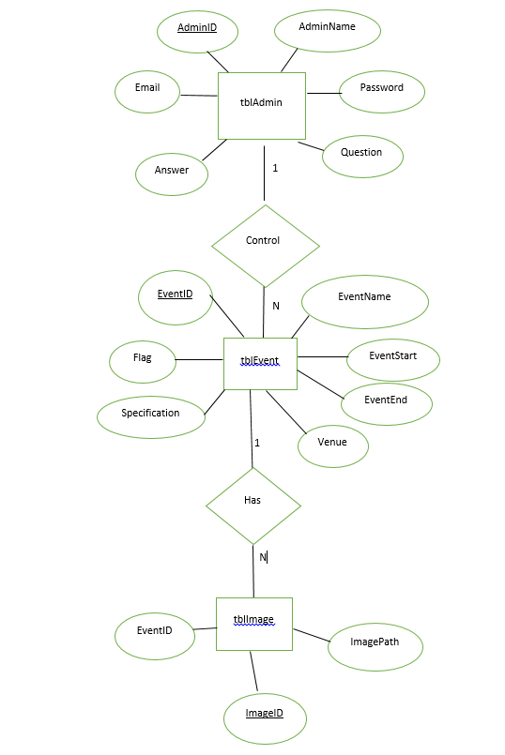

# 3. Application Workflow

## 3.1 Major Functionalities

**View past event module**

Accessible to employees. Employee will be provided with the right of view information.

Employee select event from past event list and event description and image gallery displays for that specific event.

**View upcoming event module**

Accessible to employees. Employee will be provided with the right of view information.

Employee select event from upcoming event list. Event description and images are displayed for that event.

**Admin login module**

This function will be accessible to administrator. The administrator can login with the valid

email id and password. Login detail get verified and access allowed to verified admin.

Admin activity page displayed.

**Add event module**

Admin will have the authorization for adding the new event’s information.

Admin can create new event by entering event and the event should get added to upcoming event list.

**Personalize module**

Admin will have the authorization for adding the new images to the carousel.

Page for uploading carousel image should displayed and Admin can Upload 5 images for carousel and the image should get added to carousel grid.

**Edit event module**

Admin will have the authorization for editing the event’s information. Page for editing event information should displayed and Admin can edit event by entering the changed event information and the event should get edited to event list.

**Delete event module**

Admin will have the authorization for deleting the event’s information. Dialogue box for delete confirmation should displayed and Admin can delete the event after the confirmation. All the data i.e. images and information get deleted.

**Upload images for past event module**

Admin will have the authorization for adding the zip images to the past event.

Page for uploading zip images should displayed and Admin can upload zip images for the past event and the image should get added to that event.

## 3.2 Overall Workflow Diagram

**LEVEL 0**

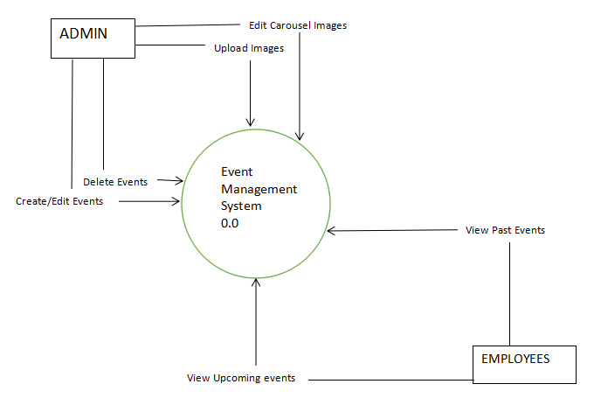

**LEVEL 1**

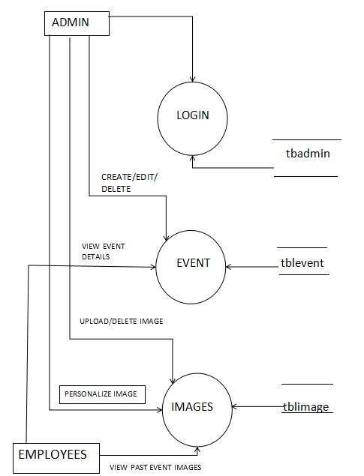

## 3.3 Integration Sequence

**View past event module**

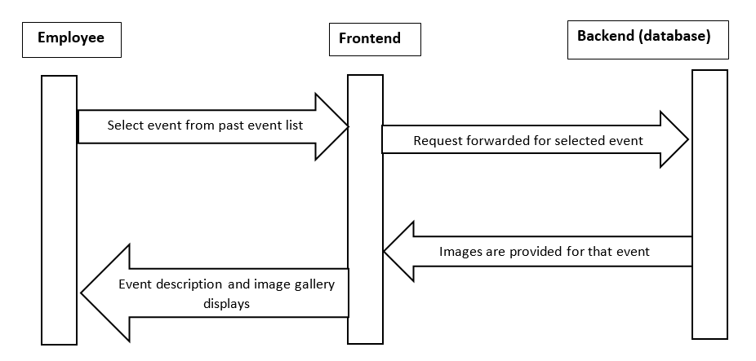

**View upcoming event module**

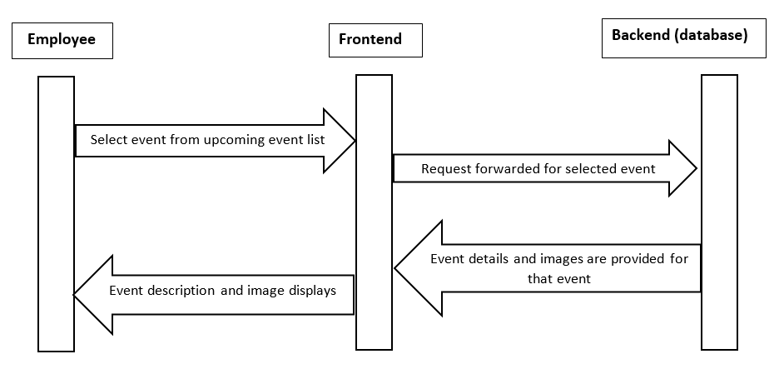

**Admin login module**

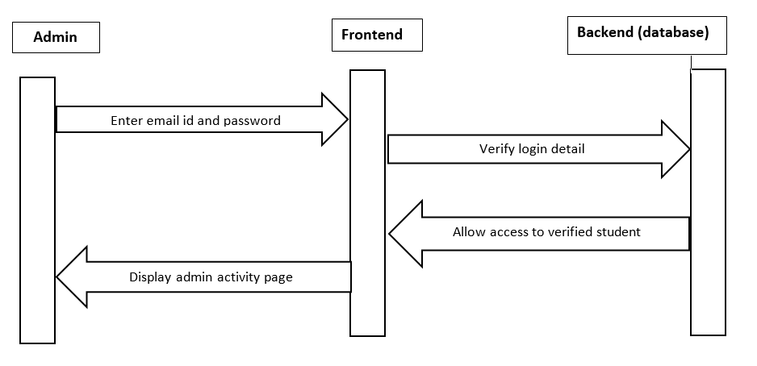

**Add event module**

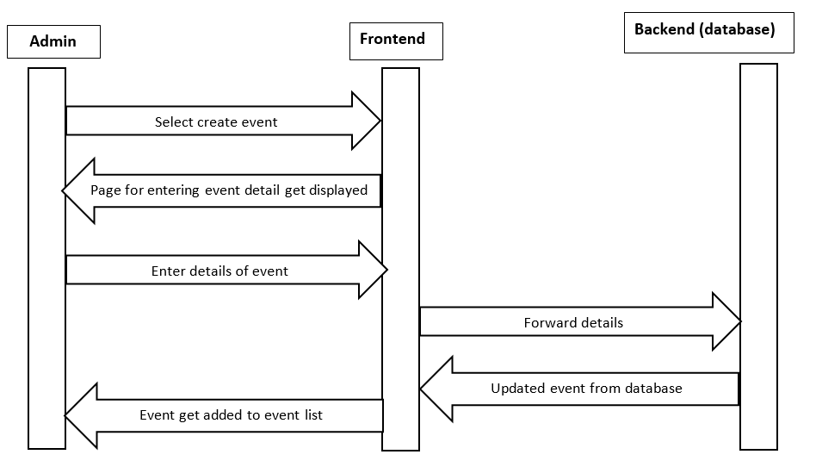

**Personalize module**

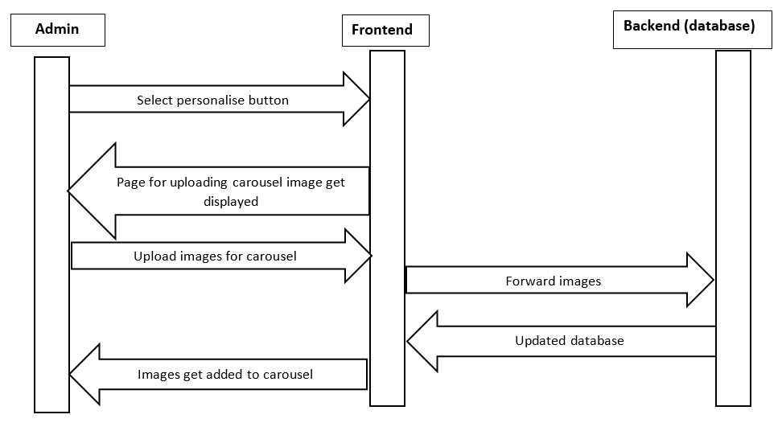

**Edit event module**

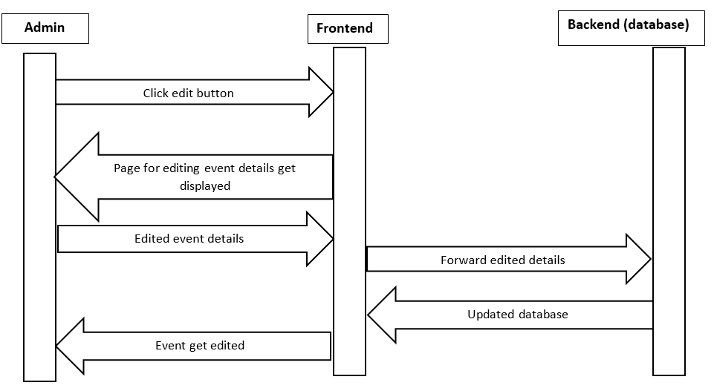

**Delete event module**

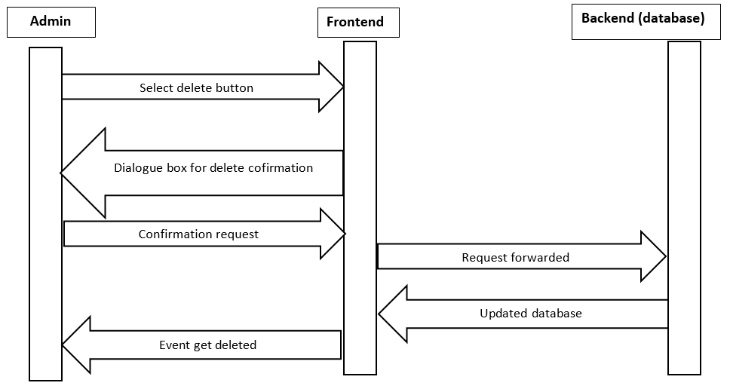

**Upload images for past event module**

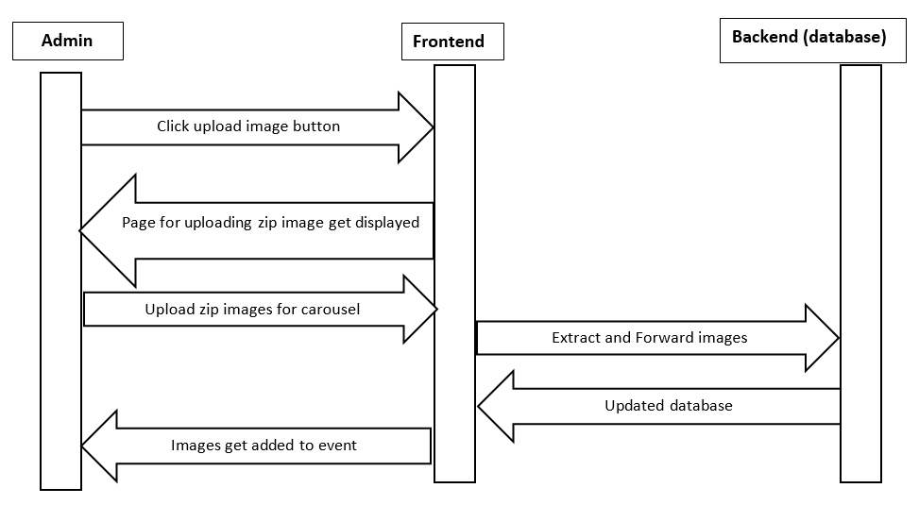

# 4. DATABASE DETAILS

## 4.1 Introduction

* Databases are needed to offer quick access to data, which makes the Internet a practical resource.
* SQL server (Relation Database) is used. It's structured to recognize relations between stored items of information. The data will be stored in the tabular form. i.e., rows and columns and has the facility to process queries faster.

**4.2 Database Schema**

**tblAdmin Table**

|  |  |  |  |  |  |
| --- | --- | --- | --- | --- | --- |
| AdminID | AdminName | Password | Email | Question | Answer |

**tblEvent Table**

|  |  |  |  |  |  |  |
| --- | --- | --- | --- | --- | --- | --- |
| EventID | EventName | EventStart | EventEnd | Specification | Venue | Flag |

**tblImage Table**

|  |  |  |
| --- | --- | --- |
| EventID | ImageID | ImagePath |

**4.3 Data Model / Table Description**

**Admin Table**

|  |  |  |
| --- | --- | --- |
| **column name** | **data type** | **Description** |
| AdminID | (pk, int, not null) | Stores unique admin id |
| AdminName | (nvarchar(50), not null) | Stores admin name |
| Password | (nvarchar(50), not null) | Stores admin password |
| Email | (nvarchar(100), not null) | Stores admin email |
| Question | (nvarchar(100), not null) | Stores security question in case user forgets its password |
| Answer | (nvarchar(100), not null) | Stores security question answer |

**Event Table**

|  |  |  |
| --- | --- | --- |
| **column name** | **data type** | **Description** |
| EventID | (pk, int, not null) | Stores auto incremented unique event id |
| EventName | (nvarchar(50), not null) | Stores event name |
| EventStart | (datetime,not null) | Stores event start date |
| EventEnd | (datetime,not null) | Stores event end date |
| Specification | (nvarchar(500), not null) | Stores description of the event |
| Venue | (nvarchar(100), not null) | Stores event venue |
| Flag | (int, not null) | Stores binary value 0 or 1 to distinguish between past event and upcoming events |

**Image Table**

|  |  |  |
| --- | --- | --- |
| **column name** | **data type** | **Description** |
| EventID | (fk, int, not null) | Refers to E_id column of Event Table |
| ImageID | (pk, int, not null) | Stores auto incremented unique image id |
| ImagePath | (nvarchar(200), not null) | Stores path where the image is stored |

# 5. INTERFACES

**5.1 Internal Interfaces**

**5.1.1 Software Interfaces:**

**Entity framework:**for database connection, database first approach.

**Windows:**to run the project.

Asp.Net MVC

SQL Server

JQuery Bootstrap

**5.1.2 Medical Standard Interface:**

Not applicable.

**5.2 External Interfaces**

The software will have following screens or the interfaces to interact with the software to access the information.

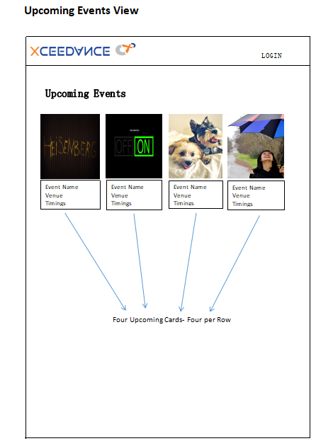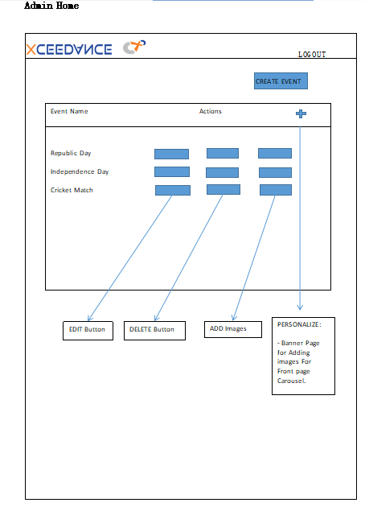

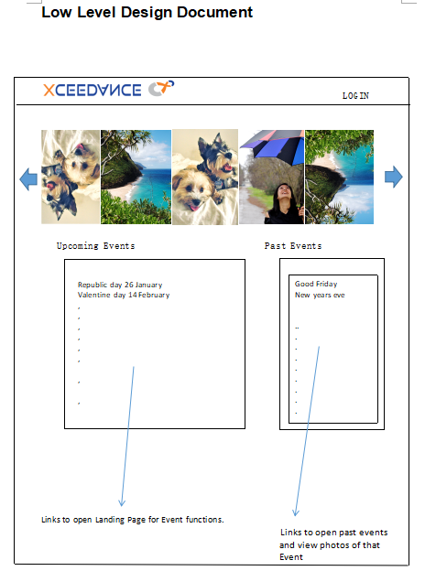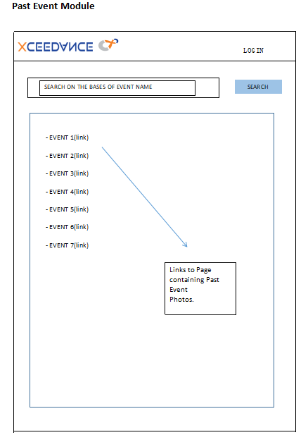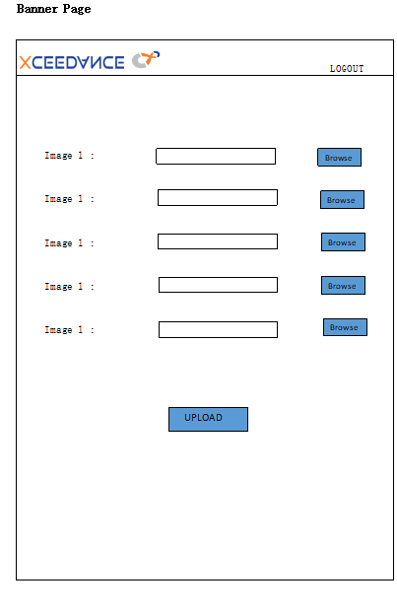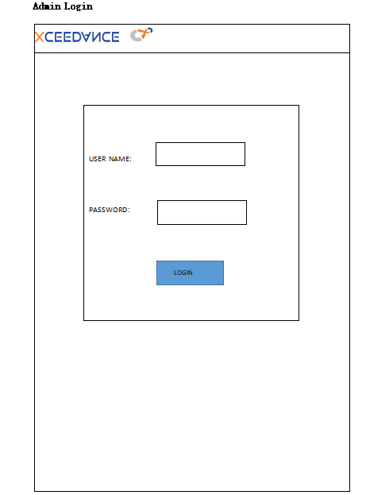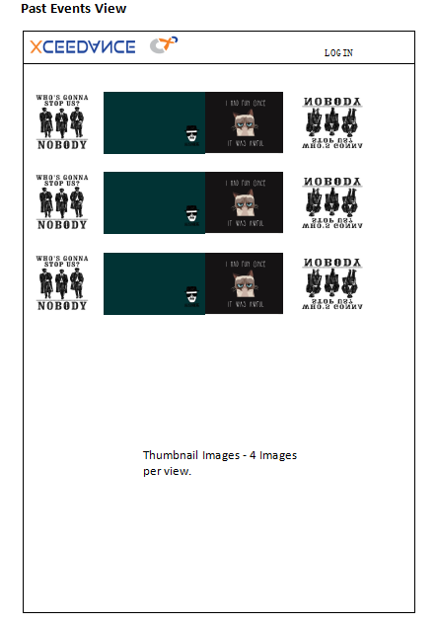

**Carousel grid**

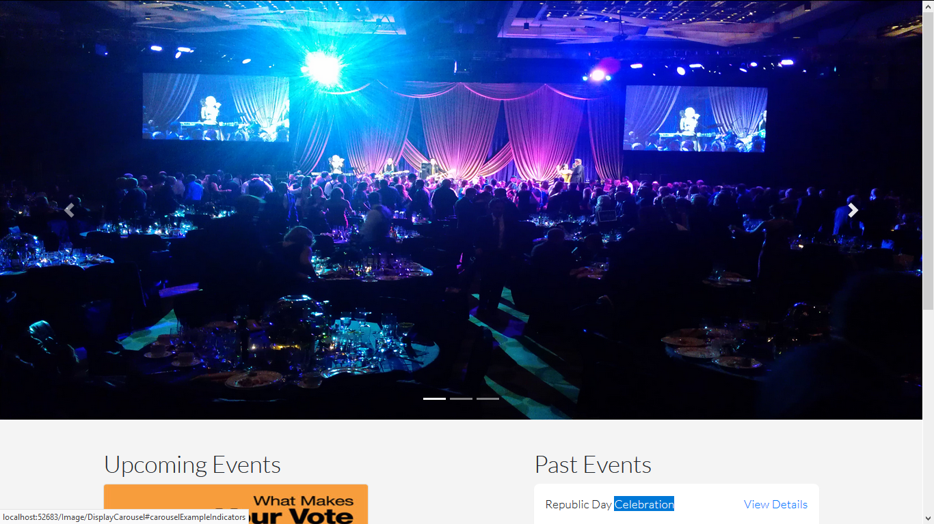

**Upcoming event and Past event grid**

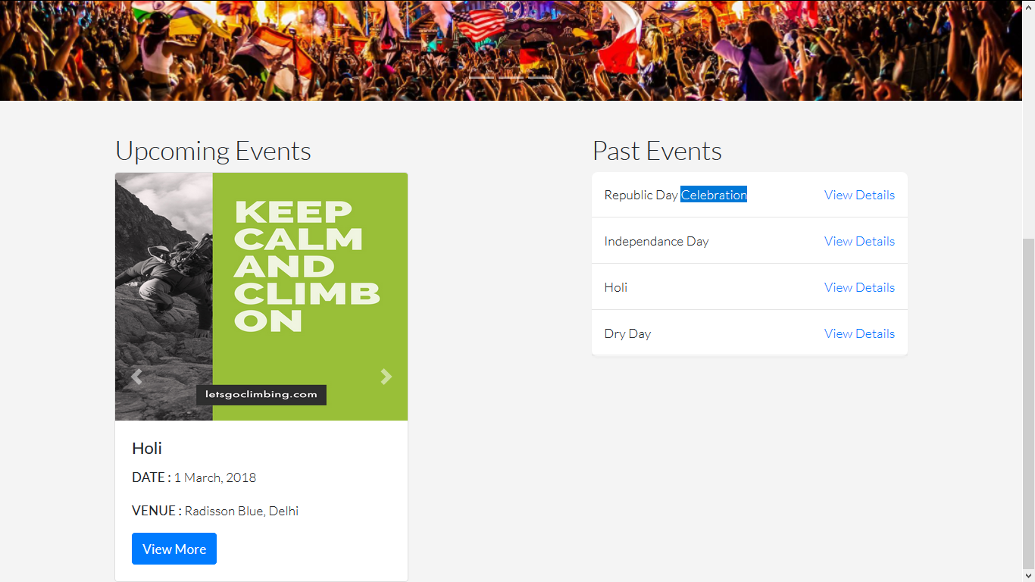

**Login Screen**

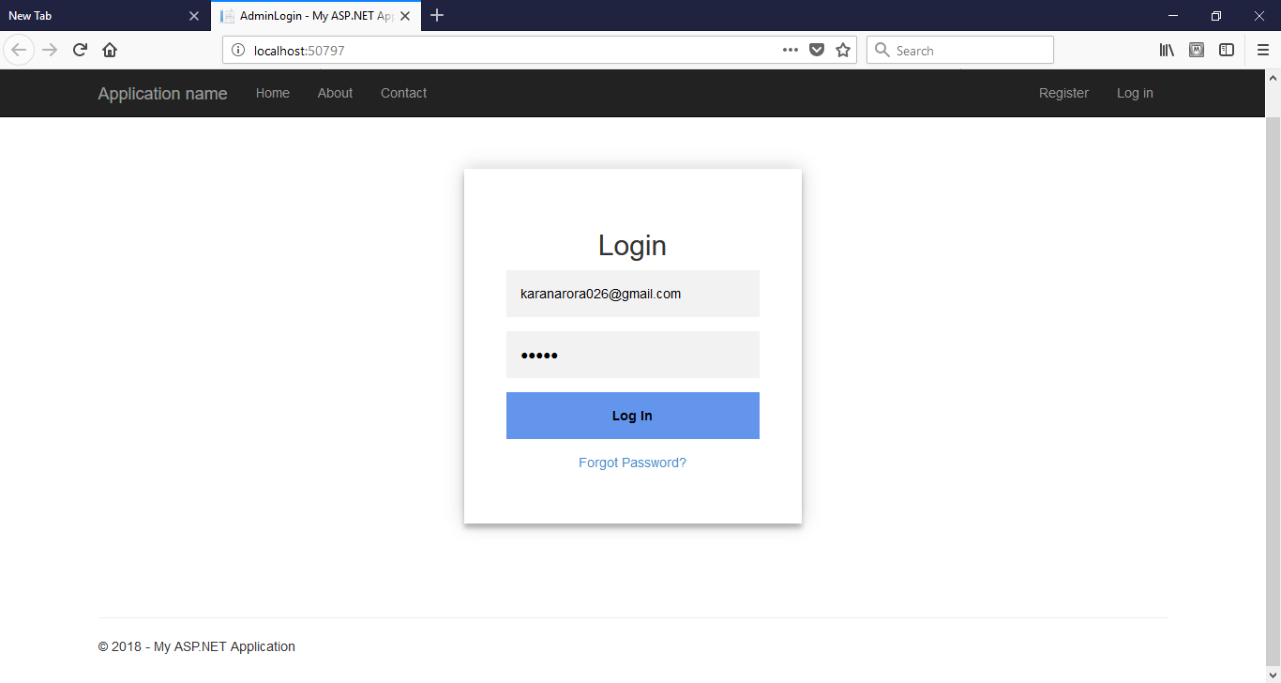

**Forgot password**

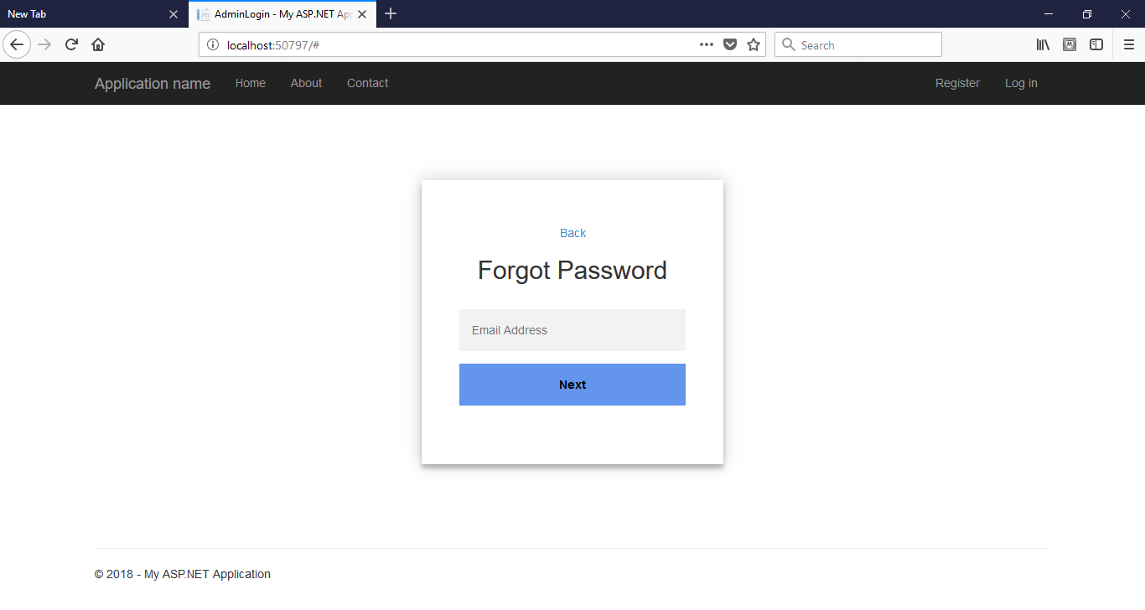

**Admin panel**

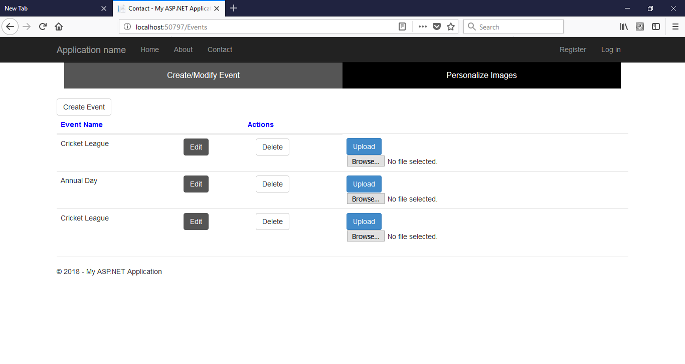

**Add event**

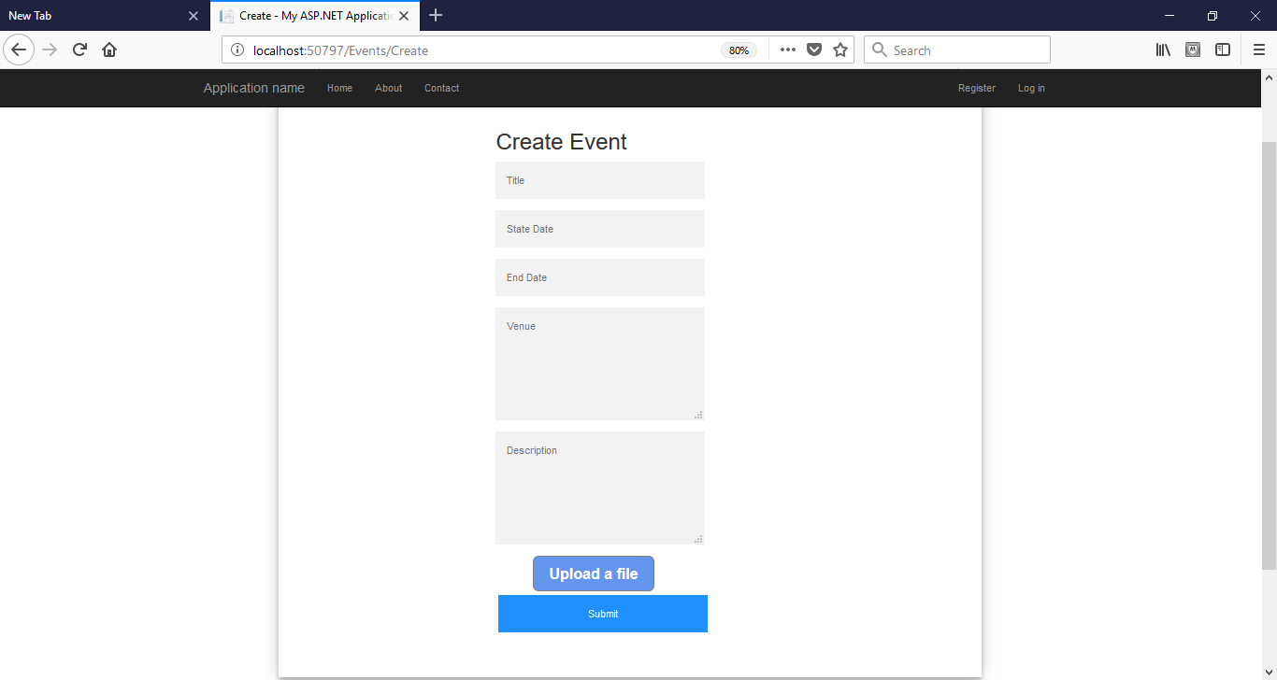

**5.3 Hardware Interfaces**

Minimum Requirements –

• A Computer with Intel Pentium III or AMD – 800 MHz Processor.

• Screen resolution of 800x600.

**5.4 Communication Interfaces**

Not applicable.